**LAB_ATKNT003**

**Using Aggregate Function**

1. Write a query to display the year of Hire date, salary count, Distinct salary count for each hire date from employee table.

Rules:

* Fetch the details only for hire date > 2010 and hire date < 2014.
* Column name of Distinct count of salary should be ‘DistinctCount’, Hire date as ‘Joining’
* Order the table based on Hiredate.

Sample output



Query:

select Year(Hire_date) as Joining, count(salary) as salary,

count(Distinct(salary)) as Distinctcount from Employees

where Year(Hire_date) > 2010 and Year(Hire_date) < 2014

group by year(Hire_date) order by year(Hire_date);

**Format Function**

1. Write a query to format the Hire date and salary on below format in Employee table.

**Rules:**

* The Hire date should be in ‘’dd/MM/yyyy’ format.
* Column name of salary should be ‘US currency’ for Dollar and ‘UK Currency’ for Pound.

**Output:**

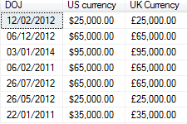

**Query:**

Select format(Hire_date,'dd/MM/yyyy') as DOJ, format(salary,'C','en-US') as 'US currency', Format(salary,'C','en-gb') as 'UK Currency' from Employees

Where Year(Hire_date) > 2010

**Using Join**

1. Write a Query to Display the details of employee.

**Rules:**

1. Column name of Job_title should be ‘Designation’
2. Order the last_name

**Sample output:**

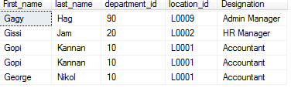

**Query :**

select e.First_name,e.last_name,d.department_id,l.location_id,Jobs.job_title as Designation

from employees e join departments_tbl d on e.Department_id=d.Department_id

join Locations_Tbl l on l.Location_Id = d.Location_Id

join job_history_tbl j on j.Employee_id=e.employee_id

join Jobs_Tbl jobs on jobs.Job_id =j.Job_id

where first_name like 'G%'

order by LAST_NAME

**Using Ranking Concept**

1. Write a query to display the rank for the column marks in the examresult table.

Rules:

1. order the result table by name,subject.

Sample Output:

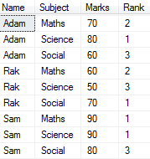 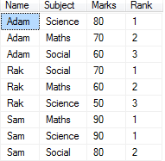

Using Rank(): Using Dense_Rank():

Query :

select Name,Subject,Marks,

RANK() over(partition by name order by Marks desc)Rank

From ExamResult

order by name,subject

select Name,Subject,Marks,

DENSE_RANK() over(partition by name order by Marks desc)Rank

From ExamResult

order by name